Order Of Service

Singing: Psalm 62—CW page 88

Reading: Psalm 129

Opening Hymn: TLH 236

Reading: James 1:12-18

Request Hymn: CW Supplement 769

Reading: Luke 18:15-17

Sermon Hymn: TLH 237

Sermon Text: Song of Solomon 1:12

The King’s Banquet

Prayer

The Apostles’ Creed, TLH page 12

Holy Communion

The Lord's Prayer

The Blessing

Closing Hymn: TLH 50

* * * * * * * * * * *

Bible Study: Lambs: Exodus 2:1-10; Getting You Ready
Sheep: Proverbs 4:20-27; Your Choice


Field of White

Water
Of
Life

30 August 2015

W A T E R O F L I F E

Independent Christian Church—Conservative Lutheran Doctrine

Worship Service: 9:30 a.m. Bible Study: 10:45 a.m.

Larry Cooper, Pastor E-Mail address:
111 N. Ridge Road lcooper@wateroflife.cc
Coon Valley, WI 54623 Web Site:
Phone: (608) 452-2105 www.wateroflife.cc

* * * * * * * * * * * * * * * * * * * * * * * * * * *

Sermon Text: Song of Solomon 1:12

The King’s Banquet

* * * * * * * * * * * * * * * * * * * * * * * * * * *

12. While the king sitteth at his table, my spikenard sendeth forth the smell thereof.

Here in verse 12 of Song of Solomon chapter 1, we have the Bride talking. And when she mentions her spikenard, we can help but think of the opening words of John 12:

John 12:1 Then Jesus six days before the passover came to Bethany, where Lazarus was which had been dead, whom he raised from the dead.
John 12:2 There they made him a supper; and Martha served: but Lazarus was one of them that sat at the table with him.
John 12:3 Then took Mary a pound of ointment of spikenard, very costly, and anointed the feet of Jesus, and wiped his feet with her hair: and the house was filled with the odour of the ointment.

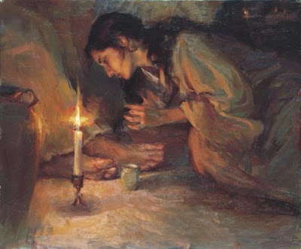

No sooner had the last drop of ointment fallen from the alabaster box than she was severely attacked by Judas Iscariot:

John 12:4 Then saith one of his disciples, Judas Iscariot, Simon's son, which should betray him,
John 12:5 Why was not this ointment sold for three hundred pence, and given to the poor?

Sadly, all of the rest of the disciples chimed in.

But here in our text the scene is far different. Satan and his wicked ones are nowhere to be seen, or heard. There is that “great gulf fixed.” And they can’t cross it. The Bride is now living in perfect peace with her Bridegroom, the King.

